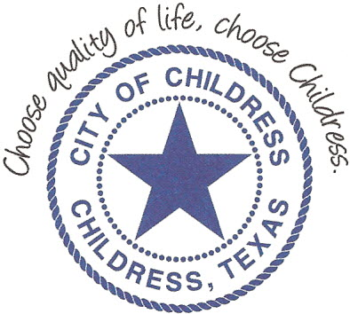
City of Childress
315 Commerce P.O. Box 1087 Childress, TX 79201
Phone: 940.937.3684 Fax: 940.937.6420

AGENDA

The City Council will meet in Called Session, Friday, September 27th, 2019 at 12:00 p.m. in the Council Chambers at City Hall, 315 Commerce St., Childress Texas to discuss the following:
Action Items

- Call meeting to order.
- Public Comment
-Open the floor for public comment. Three (3) minutes will be allowed for every citizen wishing to speak that has filled out Speaker Card.
3. Discuss/Act on FY 2018-2019 Amendment #4.
4. 2nd Reading and enactment of City Council Code of Ethics Policy.

Council may enter a closed session as permitted by the Texas Open Meetings Act, (Chapter 551 of the Texas Government Code).

____________________________
Kevin Hodges, City Manager
KH/dd
Posted 1:00 p.m. September 20th, 2019
Distribution: Index (email), KCTX Radio (email)
Sworn to and subscribed before me this the 20th day of September, 2019

____________________________________________
D’Linda Dockery, Notary Public State of Texas

