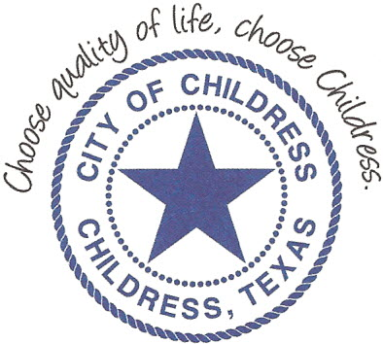
City of Childress
315 Commerce P.O. Box 1087 Childress, TX 79201
Phone: 940.937.3684 Fax: 940.937.6420

AGENDA

The City Council will meet in Called Session, Monday, July 29th, 2019 at 12:00 p.m., in the Council Chambers, Childress City Hall, 315 Commerce St., Childress Texas to discuss the following:
Action Items

- Call meeting to order.
- Establish quorum.
- Discuss/Act on Interlocal Agreements between the City of Childress and Childress County as it relates to fire protection and dispatch services.

Council may enter a closed session as permitted by the Texas Open Meetings Act, (Chapter 551 of the Texas Government Code).

____________________________
Kevin Hodges, City Manager
KH/dd
Posted 4:00 p.m. July 26th, 2019
Distribution: Index (email), KCTX Radio (email)
Sworn to and subscribed before me this the 26th day of July, 2019

____________________________________________
D’Linda Dockery, Notary Public State of Texas

