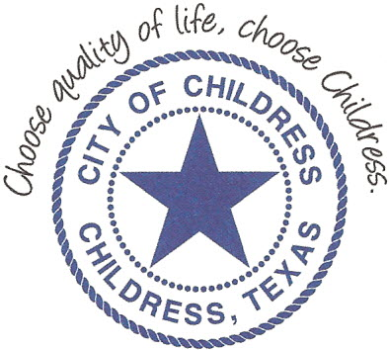
City of Childress
315 Commerce P.O. Box 1087 Childress, TX 79201
Phone: 940.937.3684 Fax: 940.937.6420

AGENDA

The City Council will meet in Regular Meeting, Monday August 24th, 2020 at 6:05 p.m. in the Expo Center at the Mashburn Event Center, 1100 7th St. NW, Childress Texas to discuss the following:
Action Items

- Call meeting to order.
- Invocation and Pledge of Allegiance.
- Public Comment.
- Approve or amend and approve previous Meeting Minutes (August 3rd, August 7th, August 10th, August 10th, August 17th)
- 2nd Reading and Approval of Water Rate Ordinance 887.
- Reading of Resolution 082420 – Regulations of and Methods of Servicing Out-of-City-Limits taps, lines, and meters.
- Discuss/Act on Handbook amendments.
- Discuss/Act on independent audit on current Budget through Foster & Lambert.
- Discuss/Act on Closed Bids for the Cemetery.
- Discuss/Act on 2020-2021 Budget.
- Discuss/Act on adopting 2020-2021 Tax Rate.

Council may enter a closed session as permitted by the Texas Open Meetings Act, (Chapter 551 of the Texas Government Code).

____________________________
Kevin Hodges, City Manager
KH/dd
Posted 12:00 P.M. August 21st, 2020
Distribution: Index (email), KCTX Radio (fax)
Sworn to and subscribed before me this the 21st day of August, 2020

____________________________________________
D’Linda Dockery, Notary Public State of Texas

