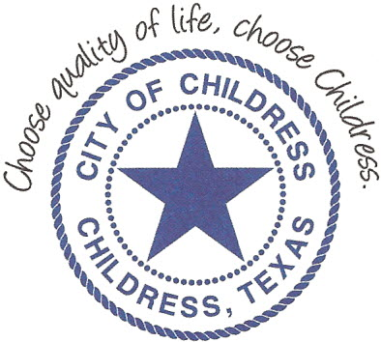
City of Childress
315 Commerce P.O. Box 1087 Childress, TX 79201
Phone: 940.937.3684 Fax: 940.937.6420

AGENDA

The City Council will meet in Called Session, Monday, March 15th, 2019 at 12:00 p.m. in the Council Chambers at City Hall, 315 Commerce St., Childress Texas to discuss the following:
Action Items

- Call meeting to order.
- Consider and act on trash truck lease/purchase agreement.

Council may enter a closed session as permitted by the Texas Open Meetings Act, (Chapter 551 of the Texas Government Code).

____________________________
Kevin Hodges, City Manager
KH/dd
Posted 10:10 a.m. March 12th, 2019
Distribution: Index (email), KCTX Radio (email)
Sworn to and subscribed before me this the 12th day of March, 2019

____________________________________________
D’Linda Dockery, Notary Public State of Texas

