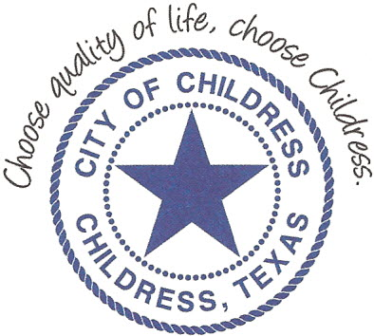
City of Childress
315 Commerce P.O. Box 1087 Childress, TX 79201
Phone: 940.937.3684 Fax: 940.937.6420

AGENDA

The City Council will meet in Called Session, Friday, August 30th, 2018 at 6:00 p.m. in the Council Chambers at Childress City Hall, 315 Commerce St., Childress Texas to discuss the following:
Action Items

- Call meeting to order.
- 1st reading of proposed FY ’18-’19 Budget.

Council may enter a closed session as permitted by the Texas Open Meetings Act, (Chapter 551 of the Texas Government Code).

____________________________
Kevin Hodges, City Manager
KH/dd
Posted 1:30 P.M. August 28th, 2018
Distribution: Index (email), KCTX Radio (fax)
Sworn to and subscribed before me this the 28th day of August 2018

____________________________________________
D’Linda Dockery, Notary Public State of Texas

