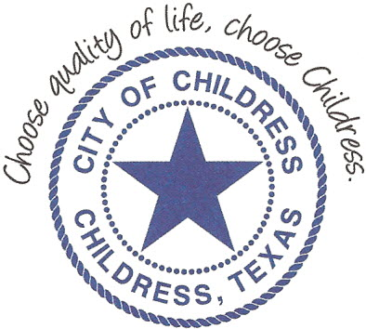
City of Childress
315 Commerce P.O. Box 1087 Childress, TX 79201
Phone: 940.937.3684 Fax: 940.937.6420

AGENDA

The City Council will meet in Regular Session, Monday, February 11th, 2019 at 6:00 p.m. in the Council Chambers at City Hall, 315 Commerce St., Childress Texas to discuss the following:
Action Items

- Call meeting to order.
- Approve or Amend/Approve Previous Meeting Minutes.
- Review Accounts Payable report.
- Discuss/Act on Outside City Limits Dumpster Request.
- Chamber of Commerce and Main Street to present Quarterly Reports.
- Council and Attorney review of Chamber of Commerce contract terms for services.
- Childress Angler’s Association to update Council on activities at Childress and Baylor Lakes.
- Call May 4th General Election.
- Order of Election for May 4th General Election.
- Discuss/Act on Holy Angels Catholic Church request for road closures at Fair Park for a Cinco De Mayo event.
- Discuss/Act on water/wastewater tap process and fees.
- Discuss and review the implementation of a Master Fee Schedule.
- Extend thanks for service of the Childress Municipal Judge.

Council may enter a closed session as permitted by the Texas Open Meetings Act, (Chapter 551 of the Texas Government Code).

____________________________
Kevin Hodges, City Manager
KH/dd
Posted 1:00 P.M. February, 8th 2019
Distribution: Index (email), KCTX Radio (email)
Sworn to and subscribed before me this the 8th day of February, 2019

____________________________________________
D’Linda Dockery, Notary Public State of Texas

