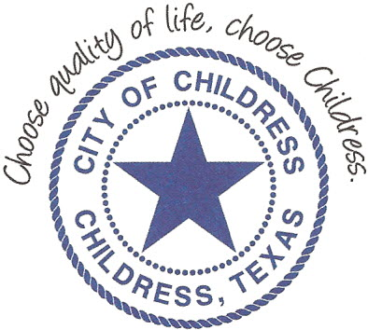
City of Childress
315 Commerce P.O. Box 1087 Childress, TX 79201
Phone: 940.937.3684 Fax: 940.937.6420

AGENDA

The City Council will meet in Called Session, Monday, December 10th, 2018 at 6:00 p.m. in the Council Chambers at City Hall, 315 Commerce St., Childress Texas to discuss the following:
Action Items

- Call meeting to order.
- Establish quorum.
- Review/Amend previous Meeting Minutes.
- Budget discussion relating to Payroll.
- Discuss use of Hotel Occupancy Tax relating to servicing City debt.
- Childress County Heritage Museum to provide Quarterly Report.
- Chamber of Commerce & Main Street to provide Quarterly Report.
- Discuss Code Enforcement electrical inspections.
- Discuss/Act on request to waive water tap charge.
- Review/Update Strategic Facilities Plan.

Council may enter a closed session as permitted by the Texas Open Meetings Act, (Chapter 551 of the Texas Government Code).

____________________________
Kevin Hodges, City Manager
KH/dd
Posted 4:30 P.M. December 7th, 2018
Distribution: Index (email), KCTX Radio (email)
Sworn to and subscribed before me this the 7th day of December, 2018

____________________________________________
D’Linda Dockery, Notary Public State of Texas

