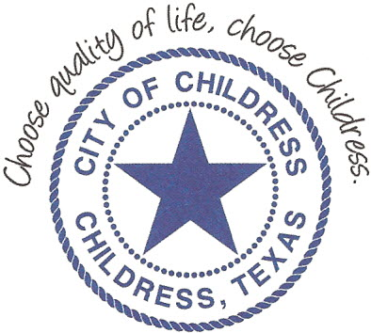
City of Childress
315 Commerce P.O. Box 1087 Childress, TX 79201
Phone: 940.937.3684 Fax: 940.937.6420

AGENDA

The City Council will meet in Regular Session, Monday August 24th, 2020 at 6:00 p.m. in the Expo Center at the Mashburn Event Center, 1100 7th St. NW, Childress Texas to discuss the following:
Action Items

- Call meeting to order.
- Public Comment.
- Public Hearing on Proposed Tax Rate for 2020-2021 Fiscal Year.

Council may enter a closed session as permitted by the Texas Open Meetings Act, (Chapter 551 of the Texas Government Code).

____________________________
Kevin Hodges, City Manager
KH/dd
Posted 12:00 P.M. August 21st, 2020
Distribution: Index (email), KCTX Radio (fax)
Sworn to and subscribed before me this the 21st day of August, 2020

____________________________________________
D’Linda Dockery, Notary Public State of Texas

